Cs403 assignment # 01
BC240413197

Question # 01 solution:

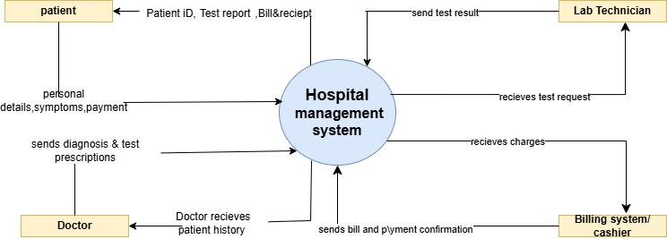
Question # 02 solution:

